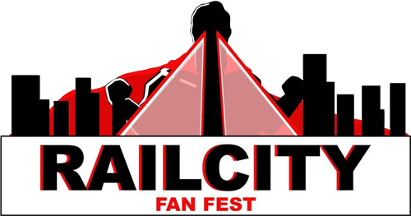

COSPLAY CONTEST REGISTRATION FORM

Contest Description:
Calling all cosplayers! Now is your chance to put your skills to the test and show off your hard work in front of a crowd. Sign up for the Rail City Fan Fest contest where you can compete against and learn from other local cosplayers.

General Contest Rules:
- Costumes may be from any form of media.
- Contestants must be at the competition area 30 minutes before the contest begins.
- All contestants must have a valid day ticket or weekend pass.
- Props/Weapons must be checked and cleared by Prop Safety.
- The contest organizer reserves the right to exclude any costume from the show that he/she/they deem inappropriate or for any reason the contest organizer determines to be sufficient. This decision is final and may not be appealed. Please remember that Rail City Fan Fest is family friendly. Flagrant nudity will not be permitted.
- No live animals.
- All contestants must register online or at the door upon entry.
- The contest director and representatives of Rail City Fan Fest have full authority to eliminate anyone from the competition on the grounds of unsportsmanlike conduct witnessed backstage, violation of the rules, or any other reason deemed sufficient. There is no appeal. Arguing with the director or representative may result in further action taken, such as a lifetime ban on participating in any future Rail City Fan Fest Costume Contests.
- Group Cosplays are allowed, however, groups can only contain up to 6 members.

Divisions:

- HARD’ACK (AGE 0-5)
Anything goes!
- STERLING (AGE 6-12)
Contestants must have at least two parts of their costume homemade.
- MANSFIELD (AGE 13-17)
Contestants must have at least four parts of their costume homemade.
- CHAMPS (18+)
Costumes must be at least 80% homemade.

Prop Safety Guidelines:
- All prop guns must have either plastic or painted orange tips.
- Offensive or overly revealing attire is prohibited. If you are asked to cover up, please comply immediately or risk ejection from the event.
- No items can have sharp or metal points.
- All props must be checked at the door upon entry and marked.
- No projectile weapons
- No explosives or flash pots.
- Metal weapons are strictly prohibited.

Rail City Fan Fest reserves the right to refuse any weapon or costume/prop into the show at any time. All props that pass through safety checks will be zip ties or tapped to show that staff has deemed them safe.
Name: Age:

What Division are you in? (Please circle one)

HARD’ACK STERLING MANSFIELD CHAMPS

Brief description of your cosplay. Please include where it’s from, what your process was, what is homemade on the costume, and anything you would like the judge’s to know!

